**Retrieving the Product Details Using the Product ID.**

**OUTPUT:**

**1.Search Product page is displayed and user is asked to enter the product id to be searched**

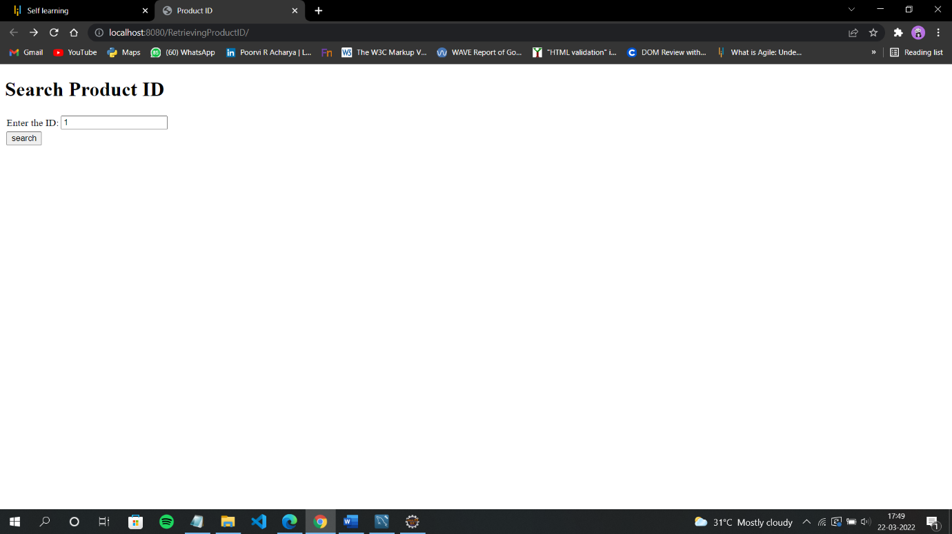

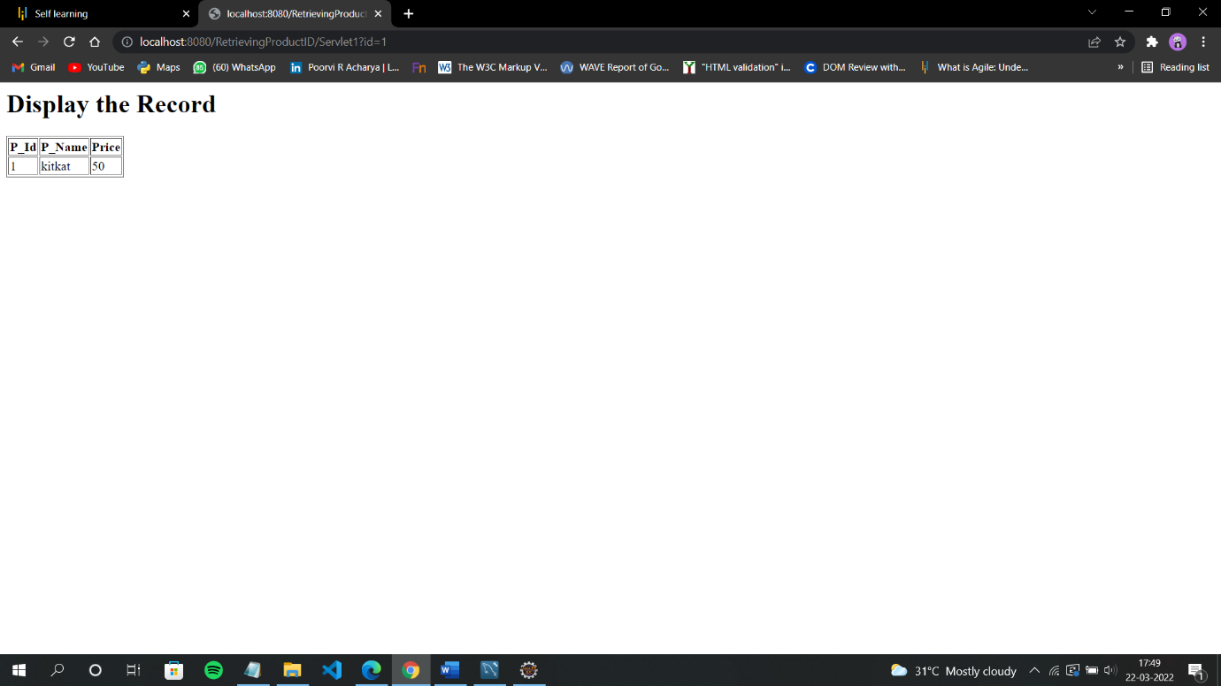**2.Record of the entered id will be Displayed as below**

**Database Table:**

